Strategic Planning Process

First Nations Financial Management Board

Table of Contents

Introduction 3
Frequently Asked Questions 3
Strategic Planning Process 6
1. Mission, Vision, Values 7
2. Current State Analysis 8
3. Strategic Priorities and Activities 10
4. Prioritization of Activities 14
5. Determination of Key Performance Indicators and Targets 15

Introduction

Developing a strategic plan is an important act of self-determination. It is a plan for the future that is reflective of the needs and vision of a First Nation. Most importantly, it is not developed by Canada or the Province but is developed by and for the First Nation. The plan reaffirms the mission and vision of the community, prioritizes strategies and reconfirms values to maintain while working towards achieving the vision.

A strategic plan acts like a road map to identify the route to take to get where the First Nation wants to go – the vision for a better future. It also serves to help coordinate the work of the First Nation, make efforts more effective and is an important reminder to stay true to the First Nation’s values. It also allows the Nation to be more accountable and transparent to the community. It is recommended that it be reviewed on a regular, 5 year basis.

The strategic planning exercise is beneficial for articulating a shared vision of the First Nation’s values, priorities, and activities. However, if it ends there, the First Nation will only realize a small fraction of the ̕benefits that might accrue through full implementation of the strategic plan. To gain the full benefit, the strategic plan must be implemented to help guide the actions of Council and the administration. This means it must remain integrated into the annual planning, decision making, and reporting of the First Nation’s government. Finally, the plan needs to remain in the minds (and hearts) of the people.

Frequently Asked Questions

- What is a strategic plan?

A strategic plan is like a road map. It identifies the place we are trying to get to – a First Nation’s shared vision for a better future. It also guides the work of the Chief and Council and the First Nation’s administration by giving them direction on how to get to the destination.

- Why is a strategic plan important?

It is an act of self-determination. It is a plan for the future that reflects the needs of the community and the vision of what the First Nation can be. A strategic plan helps to remind us what we want to achieve. It helps us to coordinate the work of many different people and make our efforts more effective. It reminds us that as we work we need to stay true to our values as a community. A strategic plan helps us to be more accountable and transparent to the community.

Strategic planning is a governance “best practice” identified by many international standards including the National Centre for First Nation’s Governance, the Native Nations Institute, the Harvard Project on American Indian Economic Development as well as the First Nations Financial Management Board under the B2 Financial Management System Standard 16.0.

- Why does it look different than other strategic plans I’ve seen?

This sample strategic plan has been developed by First Nations for First Nations. While the look and content of the plan is 100% the First Nation’s, some of the elements can be found in all strategic plans, such as: Mission, Vision, Values, Environmental Scan, Strategic Priorities, Activities and Performance Indicators.

- How is a strategic plan developed?

The strategic mission, vision, values and priorities are developed by the community. They need to be approved and adopted by General Assembly. The first set of priorities are developed by Chief and Council working with First Nation administration staff. The First Nation undertakes a process to involve community members, elected leaders, and staff. The process includes an environmental scan to provide context for the planning process. It is important to note any key observations and trends that stand out in conducting an environmental scan. All input is then incorporated into the strategic plan.

- Can a strategic plan be changed?

The mission, vision, values and priorities of the strategic plan are developed and approved by the community. No one can change these without community approval. They are intended to be the road map for the community for the long term – 25 years. This makes the strategic plan durable and focused on achieving a shared vision of the future.

The priorities are developed and approved by the Chief and Council every 5 years. This keeps the strategic plan flexible and responsive to changes in the world and allows a First Nation to build on its successes. Staff also develop annual goals and work plans based on the priorities. These goals and work plans are approved by Chief and Council through the budgeting process.

- How will it be used by Chief and Council?

Chief and Council use the strategic plan to make decisions and to increase accountability. When tough decisions need to be made leaders can turn to the strategic plan and ask “Is this decision consistent with the priorities identified by the community?” They can also ask “Is this decision consistent with the values identified by the community?” In this way, elected leaders are respecting the will of the people. Additionally, Chief and Council can use the strategic plan to monitor the performance of the First Nation’s administration. Chief and Council can ask themselves “Is the organization achieving what we have set out to achieve?” If not, why not?

Finally, Chief and Council can use the strategic plan to be accountable to the community. Chief and Council can present what they have achieved in relation to the priorities set out in the strategic plan.

- How will it be used by staff?

Staff use the strategic plan to develop their annual goals and budgets and in informing staff evaluations. Staff can ask themselves “How can I use my resources to achieve the priorities and activities in the strategic plan?” They can also ask themselves “If this activity is not helping to achieve the priorities set out in the strategic plan then why am I doing it?”

- How will it be used by community members?

Community members use the strategic plan to hold Chief and Council accountable. Is the Council achieving the priorities they set out for themselves? They also use it to recognize successes and accomplishment and to celebrate the progress towards a better future.

Strategic Planning Process

This strategic plan represents the five year planning cycle for the First Nation and builds upon the previous strategic plan. The key elements of the strategic planning process are outlined in Figure 1 below.

Figure 1 – Strategic Planning Process

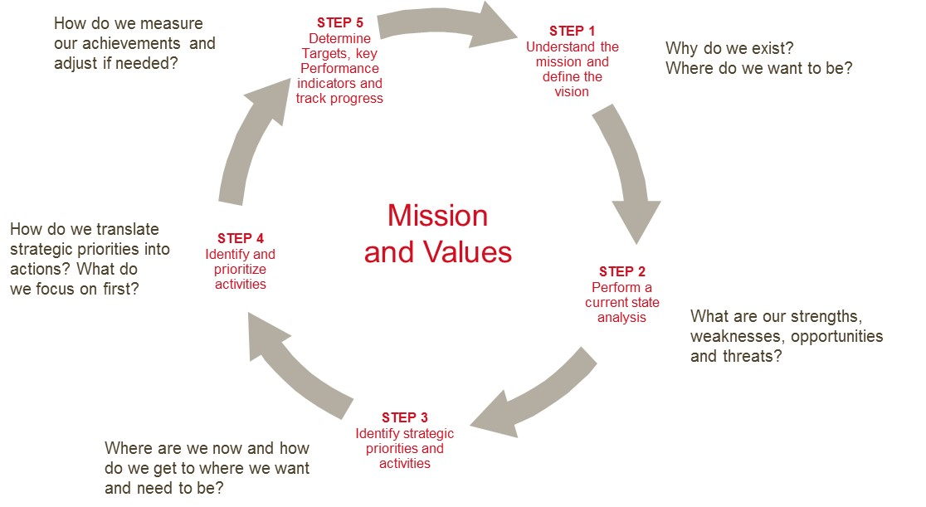

What follows in this document is a sample strategic plan that includes the following sections:

Step 1: Mission, Vision and Values;

Step 2: Current State Analysis;

Step 3: Strategic Priorities and Activities;

Step 4: Prioritization of Activities; and

Step 5: Determination of Key Performance Indicators.

Appendices:

- Annual Goal Setting and Budget Planning Template

Mission, Vision, Values

The strategic planning process reaffirms the mission and vision of the community, the strategic priorities to accomplish the vision, and reconfirms values to maintain as the First Nation works towards meeting the priorities.

Mission
This sets out why the First Nation exists, its purpose and who it is doing it for.

To improve the lives of our people both today and future generations.

Vision Statement
This is the First Nation’s ideal state, where it wants to be in the future.

The __ First Nation will be governed under our own constitution. Traditional laws will be applied to new challenges and opportunities to maximize the benefit for all the community. We will contribute as individuals and families to a healthy community that ensures our safety and security.

Values
Values are the First Nation’s source of guidance and what it stands for. They are timeless and seldom change.

Respect Responsibility Traditional language
Honesty Living Well Take only what you need
The Nation’s way of doing things Integrity Fairness

Summary of Accomplishments from Previous 5 Year Plan

It is useful to include at the beginning of the current strategic plan, key accomplishments achieved during the previous 5 year planning horizon. Figure 2 presents an example of how to summarize the First Nation’s accomplishments.

Figure 2 - Accomplishments of the First Nation’s last 5-year Strategic Plan

- Development and adoption of a Traditional Territory land use plan
- Development of protocol agreements with local and regional governments
- Creation of a land development strategy
- Creation of a Community Centre
- Creation of a Culture, Heritage, and Language Authority
- On-going support and implementation of a response to drug and alcohol addictions issues
- Development of a “Consultation and Accommodation” policy which sets out a clear process to represent the First Nation’s Title and Rights interests
- An update of the on-reserve land use plan and drafting of a Land [by-law] Law

The following activities had some progress:

- Use traditional language in all places
- Revise membership code
- Develop custom election code
- Improve Council and membership communication
- Implement the First Nation’s financial administration law
- Offer trades training and apprenticeships
- Use every opportunity to promote the First Nation’s values and principles
- Promote programs to strengthen families
- Focus on traditional preventative healing
- Increase housing opportunities
- Reduce incidence of diabetes and other chronic diseases

Activities that had significant progress and/or were completed, are not carried forward into the current strategic plan. Activities that were not completed in the last planning horizon have been incorporated into the current strategic plan.

Current State Analysis

A current state analysis or environmental scan is a review of everything that impacts the First Nation – either positively or negatively. It is an exercise to consider all assets and opportunities for the First Nation. It also identifies gaps or vulnerabilities that could impede the First Nation’s success. An environmental scan is always limited – we can never know everything or predict the future. However, it is also a useful tool to consider the operating environment that can affect the success of the First Nation’s efforts. It will be used as the basis for the risk assessment process that is described in more detail in a separate document. Figure 3 below outlines the Current State Analysis process.

Figure 3 – Current State Analysis Process
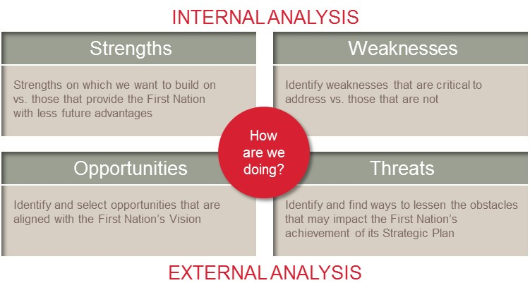
What follows is a sample summary of feedback on a First Nation’s strengths, weaknesses, opportunities and threats that would be identified by community members, staff, and Chief and Council.

Strengths

The First Nation is blessed with many strengths and natural endowments. These include a growing population, the health of the rivers and forests that sustain the people, the pride in culture and identity and especially the stable political culture. It is important to recognize and acknowledge these gifts and celebrate the strength of the First Nation. These include:

- Relationships with neighbors (First Nations, municipal governments, regional district, etc.)
- Location offers lots of opportunities for economic development
- Stable and experienced political leadership
- Committed staff personnel
- Clean drinking water
- Value driven organization and mandate
- Aboriginal title and rights recognition in law
- Size of population and skills within population
- The rural nature of the lands
- Improving housing standards
- Improving community pride
- Community involvement and input
- Very good communication and accountability
- Great facilities
- Amount of assets in the traditional territory
- Pride in heritage – language, tradition, culture

Weakness

The First Nation also has areas where improvement is needed. Some items can be addressed by Council and staff personnel while others require individual Members to be accountable. Weaknesses can be changed – they are not fixed qualities. Weaknesses identified include:

- Lack of communication between the Council, administration and the people
- Lack of interdepartmental cooperation/coordination within the organization
- Limited funding
- 2 year election cycle
- Reacting without a plan
- Continued reliance on government funding
- Not enough focus on economic development
- Huge ambitions and modest means
- Insufficient housing
- Levels of poverty and related social and health issues
- Lack of Project management capacity
- Lack of individual health and wellness

Opportunity

At times there are changes in the operating environment that can benefit the First Nation. It is important to recognize these changes and take advantage of opportunity. These include:

- Economic development with lands and partnerships with neighboring Nations
- External recognition of the First Nation’s independence
- Increased strength of culture/language/traditions
- Increased strength of community self-reliance/health/financial means
- Community population is young, growing and can be instrumental in regional economic growth
- New beginnings and lots of room to improve
- Changing governance structure to increase accountability and reduce “disconnectedness” between Council and Community
- Health self-governance

Threats

Threats are those things that the First Nation has no or little control over. That does not mean that the First Nation is helpless. It means that the First Nation has to take purposeful steps to mitigate the negative impact of those threats. These include:

- Recession resulting in lack of funding, more unemployment, and forcing the sale of lands and other assets to support programs or services
- Environmental changes (global warming, declining fish stocks, loss of glaciers)
- Lack of self-governance and autonomy (lack of recognition of our inherent right to self-government)
- Demand for natural resources – increased mining exploration, water export, energy demand, etc.
- INAC funding and policy decisions
- Fire, flood, and other natural disasters (lack of infrastructure to deal with emergency)
- Loss of language
- Racism inherent in Canadian society
- Residential school – Trauma post effects and colonization

Strategic Priorities and Activities

Based upon the Mission, Vision, Values, Previous 5 Year Prior Accomplishments and the Current State Analysis, the First Nation should determine and define between six to ten Strategic Priorities that will assist the First Nation in getting where it wants and needs to be. Below is an example of a First Nation’s Strategic Priorities and Activities.

- Priority: People learning and using Traditional Language in daily life:

This objective is important because it supports and preserves Nation’s identity and ensures the integrity of ̕the Nation as a people.

Activities to achieve this priority:

  - Develop a language retention strategy
  - Increase the use of First Voices
  - Increase the number of language learning opportunities for pre-schoolers, school aged children, youth, and adults
  - Utilize traditional language more in the workplace
  - Increase the use of traditional language in communication with external stakeholders

- Priority: Self-Determination for and by the First Nation

This objective is important because it honors the principles contained in the Declaration of the Nation’s Tribes. It is based on the inherent right of governance under the First Nation’s laws and jurisdiction.

Activities to achieve this priority:

  - Bring membership code to ratification vote
  - Develop custom election code draft for community consultation
  - Improve Council and membership communication by implementing the First Nation’s
Communication Strategy
  - Bring the financial administration bylaw to ratification vote
  - Approve and implement the First Nation’s Leadership Policy
  - Increase own-source revenues
  - Initiate a constitution development process
  - Develop a central database for information and improve overall data management
  - Increase the number of community supported by-laws
  - Increase accountability to the community by holding elections for Boards and Committees set to represent Chief and Council in specific areas

- Priority: Maximize personal economic choice and opportunity

This objective is important because people must have the freedom to choose their own destiny. It contributes to reduce poverty, increase self-sufficiency and instill individual pride and accomplishment.

Activities to achieve this priority:

  - Increase the number of community members in trades training and apprenticeships
  - Increase the number of First Nation post-secondary students graduating with Diplomas and ̕Degrees
  - Provide business training and support for community members
  - Increase the number of member owned small business operating in the territory and support current community owned small business
  - Provide infrastructure including high speed internet to the First Nation to support economic development

- Priority: Maximize economic opportunity for community benefit.

This objective is important as it generates wealth, to provide for the needs of the Nation’s people.

Activities to achieve this priority:

  - Develop and ratify a strategy to outline how profits and lump-sum payments will be used to benefit the community
  - Increase the revenues of all community Development Corporation entities ̕
  - Create community support for the land development strategy
  - Develop a comprehensive, long-term economic development strategy for the first nation
  - Increase the production value of on-reserve agriculture

- Priority: People living the “first nation’s way of doing things”

This priority is important because it creates pride in doing things the Nations’ way.

Activities to achieve this priority:

  - Develop a strategy to make the Community Centre more financially sustainable
  - Increase the number of cultural training opportunities made available to the community
  - Develop a strategy for the use and sustainability of First Nation’s lands
  - Explore alternative ways to involve community members in decision making
  - Increase the number of community members utilizing the resources of the land
  - Increase the First Nation’s connection and participation with the Cultural Centre

- Priority: Pride in a safe and secure community.

This priority is important because safety and security are fundamental to healthy and happy families.

Activities to achieve this priority:

  - Reduce drug and alcohol misuse in the community
  - Reduce the number of dogs running loose in the community
  - Decrease the number of children being removed from the community by increasing the capacity for foster care within the community
  - Increase the visibility of Tribal Police in community and explore the idea of using traditional methods of dealing with crime
  - Decrease the incidents of violence
  - Reduce vandalism of public buildings
  - Develop and enforce garbage disposal bylaws
  - Increase recycling rates and reduce solid waste in landfill by utilizing new recycling facility
  - Dedicate resources to developing a youth centre
  - Develop a building maintenance plan for community buildings
  - Improve emergency operations
  - Protect the community from nuisance and large scale flooding

- Priority: Excellence in education.

This priority is important because there is a direct link between education levels and income. That is, education is the clearest way to reduce poverty.

Activities to achieve this priority:

  - Increase academic standing of all of the Nation’s graduates
  - Increase the number of students receiving life skills and career planning advice and guidance
  - Increase the academic readiness of 12 graduates to enter post-secondary or trades training
  - Implement a student evaluation system so learning improvements can be measured
  - Clearly define “excellence” with community input so performance can be measured
  - Increase student knowledge of the First Nation’s history and culture
  - Increase number of graduates that are fluent/semi fluent speakers
  - Negotiate jurisdiction of education for our own community
- Priority: Maximum control over the First Nation’s Traditional Territory

This priority is important because of the First Nation’s principle that the land and the people are one. The ̕first nation must provide the stewardship of their own lands to ensure that it can sustain a healthy community.

Activities to achieve this priority:

  - Make consultation decisions consistent with the First Nation’s Traditional Territory Land Use Plan
  - Increase the First Nation’s physical presence across the Traditional Territory
  - Increase knowledge and awareness of territorial boundaries and resources within the first nation’s traditional territory
  - Implement the community land use plan and land law and review as necessary
  - Develop formal protocol agreements with First Nations that claim “overlap” interests within the First Nation’s Traditional Territory ̕
  - Increase awareness of Traditional Use Studies and Aboriginal Interest and Use Studies
  - Register all traditional holdings on reserve

- Priority: “living a healthy lifestyle”

This priority is important because it is the foundation for a stronger, more harmonious and ultimately more fulfilling community life.

Activities to achieve this priority:

  - Increase awareness of the health and healing qualities of traditional practices and lifestyle
  - Increase the number and diversify the type of housing units on reserve while ensuring that existing houses are utilized to their maximum potential
  - Reduce incidence of diabetes and other chronic diseases
  - Increase the number of community members participating in physical exercise and recreation programs and create new programs
  - Improve access to mental health and addictions information and support services
  - Increase elder and youth participation in all activities

Prioritization of Activities

Determining which activities to focus on first is one of the greatest challenges of implementing a strategic plan. A process to prioritize the activities needs to be undertaken in order to focus the First Nation’s resources in implementing its strategic plan. The key benefits and costs of each activity should be outlined as much as possible. Figure 4 below outlines this process.

Figure 4 – Activity Prioritization Process

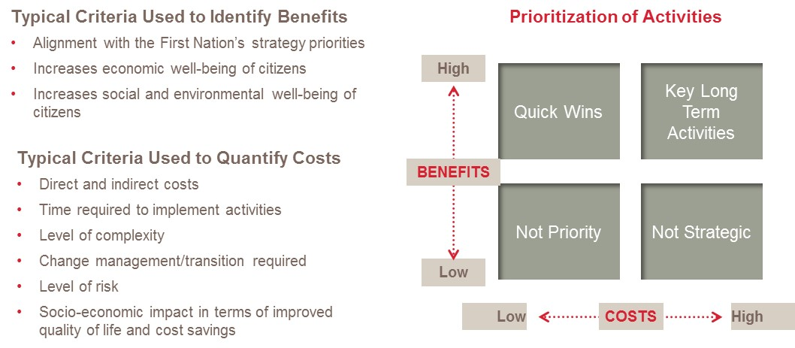

The above analysis can be organized into tables shown in Figure 5 on the following page.

Figure 5 – Activity Table

Strategic Priority:
Activities | Owner | Timeline | Estimated Benefits | Estimated Costs | Risk Mitigation Measures

Based upon each activity’s cost/benefit analysis, the First Nation can now prioritize all of the activities identified for each strategic priority. This prioritization of activities will be reflected in the multi-year financial plan as well as the annual budget, which are described in more detail in separate documents.

Determination of Key Performance Indicators and Targets

Based on the strategic priority, each activity should have specific key performance indicators that are S.M.A.R.T. - Specific, Measurable, Attainable, Realistic and Timely, making the vision more concrete by defining how success is measured. Performance indicators are used to monitor progress towards strategic priorities, closing the gap between the current state and the future state, as defined by the vision. They will help track the realization of strategic priorities, measuring the progress towards realizing the vision. Performance indicators should focus on desired outcomes for strategic priorities. Outcomes focus on what difference is being made.

When determining key performance indicators, the following principles should be kept in mind:

- Link to the First Nation’s strategic priorities;
- Limit to the select few that measure success;
- Guide desired decisions and behaviours;
- Can be easily understood and measured; and
- Are relevant to all of the First Nation’s departments.

Once the First Nation has defined its key performance indicators, targets can be set, which are the value of a key performance indicator at a specific moment in time. Targets can be set on a yearly basis or by the end of the 5 year plan and tend to focus on outputs or what is being done.

In order to keep track of the progress towards achieving the strategic plan and the First Nation’s vision, a process must be put in place and a strategic scorecard must be developed. An owner should be identified for this process and the frequency of reporting should be specified and should aim to be at least annually, if not quarterly.

It is possible that certain activities may need to be revisited due to changes in the internal and external environment, and reprioritized depending on the results attained each year.

Significant Changes between Previous 5 Year Plan and Current 5 Year Plan

Once the current 5-year strategic plan has been outlined, it is useful to highlight any significant changes between the previous and current 5-year plans. An example of this is outlined below.

Mission and Vision Statement: There are no changes: the mission and vision statement remains powerful and have not changed since developed and continue to resonate. They are viewed as a good, long-term (20+ years) mission and vision statement.

Values: The First Nation’s values articulated in the previous Strategic Plan remain fundamental to the First Nation. The only change is to amend one duplicate value statement to reflect the desire to emphasize the First Nation’s value of wellness and living healthy. All of the First Nation’s values should inform the implementation of the strategic plan and all the work of the First Nation’s government.

Strategic Priorities: The strategic priorities identified in the previous 5-year strategic plan remain important to the community today. The only modification is to emphasize the “self-determination” of the First Nation in the strategic priority that deals with governance of the First Nation.

5 Year Activities: The previous strategic plan contained _ _ activities; the new strategic plan contains __ activities. The __ activities contained within the current strategic plan are a mix of new ideas, modifications to preexisting activities and inclusion of some that that did not have enough progress in the last strategic plan term. The increase in activities is reflective of greater participation and input in establishing the activities, and more specific and measurable targets.

Implementation Suggestions

The strategic planning exercise is beneficial in itself for articulating a shared vision of the Nation’s values, priorities, and activities. If it ends there, however, the First Nation will only realize a small fraction of the ̕benefits that might accrue through full implementation of the strategic plan. In order to gain the full benefit of the strategic plan, it must be implemented in a way that helps to guide all actions of Council and administration. For example, it must remain integrated in annual planning, decision making, and reporting of the First Nation’s government. Finally, it must also remain in the minds (and hearts) of the people.

Ways to do this include:

- Chief and Council carry the strategic plan at all times;
- Council review the strategic plan as part of orientation activities after each election;
- Senior Managers carry the strategic plan with them at all times;
- Staff review the strategic plan at least once annually;
- The strategic plan is used to set annual goals and allocate financial resources (budgeting);
- Use as the basis for staff reports to Council;
- Use as the basis for Council reports to the community;
- Align Chief and Council portfolios to the strategic priorities;
- Post the strategic plan in all community buildings; and
- Post the strategic plan prominently on the First Nation’s website.

Appendix A - Annual Goal Setting & Budget Planning Template

Example #1 of how staff can formulate annual goals related to the strategic priorities and activities contained in the strategic plan.

Strategic Priority: Pride in a safe and secure community.
Activity: Decrease the number of the First Nation’s children removed from the community by increasing the capacity for the First Nation’s foster care.

Examples of possible annual goals | Activities required to achieve the goal | Lead staff responsible for the activities | Others to contribute | Financial resources required
2 more foster homes in the First Nation
Engage in a government to government relationship with the Province of BC to
enshrine the Nation’s principles as the basis for child protection matters
Determine what administrative capacity is required to move toward community
based mediations with families rather
than the court system
Build awareness of the need for taking responsibility and having more foster homes within the community
Development of the First Nation’s standards within home – recognition of the First Nation’s standards
Provide support for foster parents by creating a foster parent support group
Recognition of caregivers in community

Example #2 of how staff can formulate annual goals related to the strategic priorities and activities contained in the strategic plan.

Strategic priority: Maximum personal economic choice.
Activities: Increase the number of small business operating on reserve.

Examples of possible annual goal | Activities required to achieve the goal | Lead staff responsible for the goal | Others to contribute | Financial resources required
Identify and promote small business opportunities in area
Create zoning for small business (provide land for
business)
Provide access to seed capital
Offer support with business plan writing
Celebrate local entrepreneurs
Provide business courses
Leadership increases awareness of their role in
creating an environment for small business to flourish

Example #3 of how staff can formulate annual goals related to the strategic priority and activities contained in the strategic plan.

Strategic Priority: People learning and using the First Nation’s language in daily life.
Activity: More First Nation language in the workplace.

Examples of possible annual goal | Activities required to achieve the goal | Lead staff responsible for the goal | Others to contribute | Financial resources required
E-mail a new word each day to all staff
Twitter a new word each day to the First Nation’s facebook members
Require staff to introduce themselves in language at all
meetings
Assign First Nation language names for all nation assets and departments
Change all signs to bi-lingual signs
Record bi-lingual telephone greetings at reception
Short programs of learning for daycare students and
instructors

See Appendix A: Goal Setting and Budget Template.

